**Week 5 Assignment:**

Hands-On Exercises: Authentication and Authorization in ASP.NET Core Web API Microservices This document contains 4 hands-on exercises focusing on Authentication and Authorization in ASP.NET Core Web API microservices, with an emphasis on implementing JWT (JSON Web Tokens) authentication. Each exercise includes a scenario, step-by-step instructions, and complete solution code.

**Question 1: Implement JWT Authentication in ASP.NET Core Web API**  
  
  
 Program:

Controller:

[AuthController.cs](http://authcontroller.cs)

using Microsoft.AspNetCore.Mvc;

using JwtAuthApi.Models; // adjust if needed

using Microsoft.IdentityModel.Tokens;

using System.IdentityModel.Tokens.Jwt;

using System.Security.Claims;

using System.Text;

namespace JwtAuthApi.Controllers

{

[ApiController]

[Route("api/[controller]")]

public class AuthController : ControllerBase

{

[HttpPost("login")]

public IActionResult Login([FromBody] LoginModel model)

{

if (model.Username == "admin" && model.Password == "password")

{

var token = GenerateJwtToken(model.Username);

return Ok(new { Token = token });

}

return Unauthorized();

}

private string GenerateJwtToken(string username)

{

var claims = new[]

{

new Claim(ClaimTypes.Name, username)

};

var key = new SymmetricSecurityKey(Encoding.UTF8.GetBytes("ThisIsASecretKeyForJwtToken"));

var creds = new SigningCredentials(key, SecurityAlgorithms.HmacSha256);

var token = new JwtSecurityToken(

issuer: "MyAuthServer",

audience: "MyApiUsers",

claims: claims,

expires: DateTime.Now.AddMinutes(60),

signingCredentials: creds

);

return new JwtSecurityTokenHandler().WriteToken(token);

}

}

}

[TestController.cs](http://testcontroller.cs)

using Microsoft.AspNetCore.Mvc;

namespace JwtAuthApi.Controllers

{

[ApiController]

[Route("api/[controller]")]

public class TestController : ControllerBase

{

[HttpGet("hello")]

public IActionResult SayHello()

{

return Ok("Hello from TestController");

}

}

}

[Program.cs](http://program.cs)

using Microsoft.AspNetCore.Authentication.JwtBearer;

using Microsoft.IdentityModel.Tokens;

using System.Text;

var builder = WebApplication.CreateBuilder(args);

builder.Services.AddControllers();

builder.Services.AddEndpointsApiExplorer();

builder.Services.AddSwaggerGen();

// JWT Auth config

builder.Services.AddAuthentication("Bearer")

.AddJwtBearer("Bearer", options =>

{

options.TokenValidationParameters = new TokenValidationParameters

{

ValidateIssuer = true,

ValidateAudience = true,

ValidateLifetime = true,

ValidateIssuerSigningKey = true,

ValidIssuer = builder.Configuration["Jwt:Issuer"],

ValidAudience = builder.Configuration["Jwt:Audience"],

IssuerSigningKey = new SymmetricSecurityKey(

Encoding.UTF8.GetBytes(builder.Configuration["Jwt:Key"]))

};

});

builder.Services.AddAuthorization();

var app = builder.Build();

app.UseSwagger();

app.UseSwaggerUI();

app.UseHttpsRedirection();

app.UseAuthentication(); // <-- Important

app.UseAuthorization();

app.MapControllers();

app.Run();

OutPut:

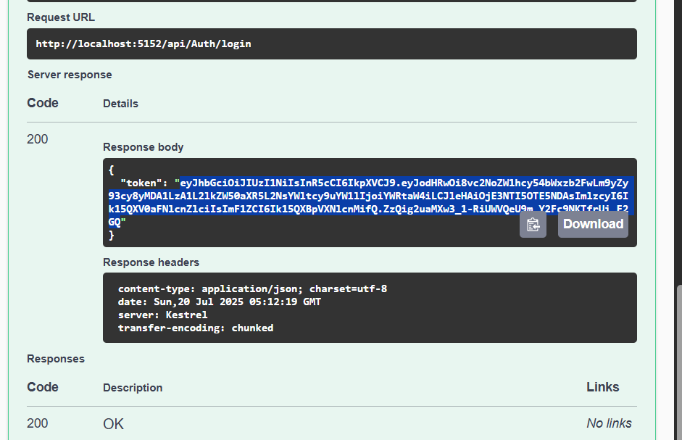

Question 2: Secure an API Endpoint Using JWT  
  
Countroller:

[AuthController.cs](http://authcontroller.cs)

using Microsoft.AspNetCore.Mvc;

using JwtAuthApi.Models; // adjust if needed

using Microsoft.IdentityModel.Tokens;

using System.IdentityModel.Tokens.Jwt;

using System.Security.Claims;

using System.Text;

namespace JwtAuthApi.Controllers

{

[ApiController]

[Route("api/[controller]")]

public class AuthController : ControllerBase

{

[HttpPost("login")]

public IActionResult Login([FromBody] LoginModel model)

{

if (model.Username == "admin" && model.Password == "password")

{

var token = GenerateJwtToken(model.Username);

return Ok(new { Token = token });

}

return Unauthorized();

}

private string GenerateJwtToken(string username)

{

var claims = new[]

{

new Claim(ClaimTypes.Name, username)

};

var key = new SymmetricSecurityKey(Encoding.UTF8.GetBytes("ThisIsASecretKeyForJwtToken"));

var creds = new SigningCredentials(key, SecurityAlgorithms.HmacSha256);

var token = new JwtSecurityToken(

issuer: "MyAuthServer",

audience: "MyApiUsers",

claims: claims,

expires: DateTime.Now.AddMinutes(60),

signingCredentials: creds

);

return new JwtSecurityTokenHandler().WriteToken(token);

}

}

}

SecureController.cs

using Microsoft.AspNetCore.Authorization;

using Microsoft.AspNetCore.Mvc;

namespace JwtAuthApi.Controllers

{

[ApiController]

[Route("api/[controller]")]

public class SecureController : ControllerBase

{

[HttpGet("data")]

[Authorize]

public IActionResult GetSecureData()

{

return Ok("This is protected data.");

}

}

}

[Program.cs](http://program.cs)

using Microsoft.AspNetCore.Authentication.JwtBearer;

using Microsoft.OpenApi.Models;

using Microsoft.IdentityModel.Tokens;

using System.Text;

var builder = WebApplication.CreateBuilder(args);

var configuration = builder.Configuration;

builder.Services.AddControllers();

builder.Services.AddEndpointsApiExplorer();

builder.Services.AddSwaggerGen();

// JWT Auth config

builder.Services.AddAuthentication("Bearer")

.AddJwtBearer("Bearer", options =>

{

options.TokenValidationParameters = new TokenValidationParameters

{

ValidateIssuer = true,

ValidateAudience = true,

ValidateLifetime = true,

ValidateIssuerSigningKey = true,

ValidIssuer = configuration["Jwt:Issuer"],

ValidAudience = configuration["Jwt:Audience"],

IssuerSigningKey = new SymmetricSecurityKey(

Encoding.UTF8.GetBytes(configuration["Jwt:Key"]))

};

});

builder.Services.AddAuthorization();

var app = builder.Build();

app.UseSwagger();

app.UseSwaggerUI();

app.UseHttpsRedirection();

app.UseAuthentication(); // <-- Important

app.UseAuthorization();

app.MapControllers();

app.Run();

Output:

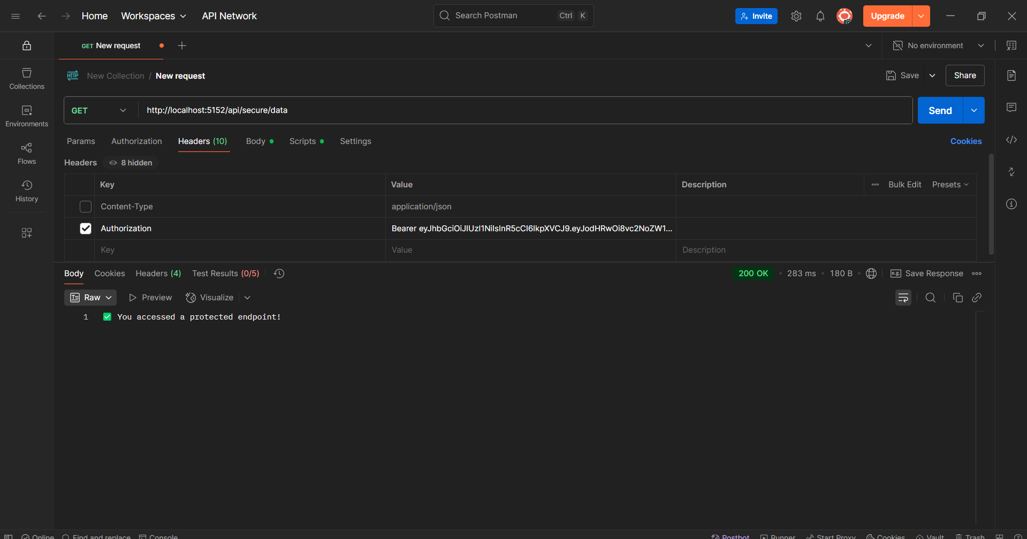



Question 3: Add Role-Based Authorization:

Program:

Controller:

[AuthController.cs](http://authcontroller.cs):

using Microsoft.AspNetCore.Mvc;

using Microsoft.IdentityModel.Tokens;

using System.IdentityModel.Tokens.Jwt;

using System.Security.Claims;

using System.Text;

using JwtAuthApi.Models;

namespace JwtAuthApi.Controllers

{

[ApiController]

[Route("api/[controller]")]

public class AuthController : ControllerBase

{

private readonly IConfiguration _configuration;

public AuthController(IConfiguration configuration)

{

_configuration = configuration;

}

[HttpPost("login")]

public IActionResult Login([FromBody] LoginModel model)

{

// Dummy login check — in real app, check against DB

if (model.Username == "admin" && model.Password == "password")

{

var token = GenerateJwtToken(model.Username);

return Ok(new { Token = token });

}

return Unauthorized();

}

private string GenerateJwtToken(string username)

{

var claims = new[]

{

new Claim(ClaimTypes.Name, username),

new Claim(ClaimTypes.Role, "Admin") // 🔐 Add Admin role claim

};

var key = new SymmetricSecurityKey(

Encoding.UTF8.GetBytes(_configuration["Jwt:Key"]));

var creds = new SigningCredentials(key, SecurityAlgorithms.HmacSha256);

var token = new JwtSecurityToken(

issuer: _configuration["Jwt:Issuer"],

audience: _configuration["Jwt:Audience"],

claims: claims,

expires: DateTime.Now.AddMinutes(60),

signingCredentials: creds

);

return new JwtSecurityTokenHandler().WriteToken(token);

}

}

}

[AdminController.cs](http://admincontroller.cs)

using Microsoft.AspNetCore.Authorization;

using Microsoft.AspNetCore.Mvc;

namespace JwtAuthApi.Controllers

{

[ApiController]

[Route("api/[controller]")]

public class AdminController : ControllerBase

{

[HttpGet("dashboard")]

[Authorize(Roles = "Admin")]

public IActionResult GetAdminDashboard()

{

return Ok("Welcome to the admin dashboard.");

}

}

}

[LoginModel.cs](http://loginmodel.cs)

namespace JwtAuthApi.Models

{

public class LoginModel

{

public string Username { get; set; } = string.Empty;

public string Password { get; set; } = string.Empty;

}

}

[Program.cs](http://program.cs):

using Microsoft.AspNetCore.Authentication.JwtBearer;

using Microsoft.IdentityModel.Tokens;

using System.Text;

var builder = WebApplication.CreateBuilder(args);

builder.Services.AddControllers();

builder.Services.AddEndpointsApiExplorer();

builder.Services.AddSwaggerGen();

// JWT Auth config

builder.Services.AddAuthentication("Bearer")

.AddJwtBearer("Bearer", options =>

{

options.TokenValidationParameters = new TokenValidationParameters

{

ValidateIssuer = true,

ValidateAudience = true,

ValidateLifetime = true,

ValidateIssuerSigningKey = true,

ValidIssuer = builder.Configuration["Jwt:Issuer"],

ValidAudience = builder.Configuration["Jwt:Audience"],

IssuerSigningKey = new SymmetricSecurityKey(

Encoding.UTF8.GetBytes(builder.Configuration["Jwt:Key"]))

};

});

builder.Services.AddAuthorization();

var app = builder.Build();

app.UseSwagger();

app.UseSwaggerUI();

app.UseHttpsRedirection();

app.UseAuthentication(); // <-- Important

app.UseAuthorization();

app.MapControllers();

app.Run();

OutPut:

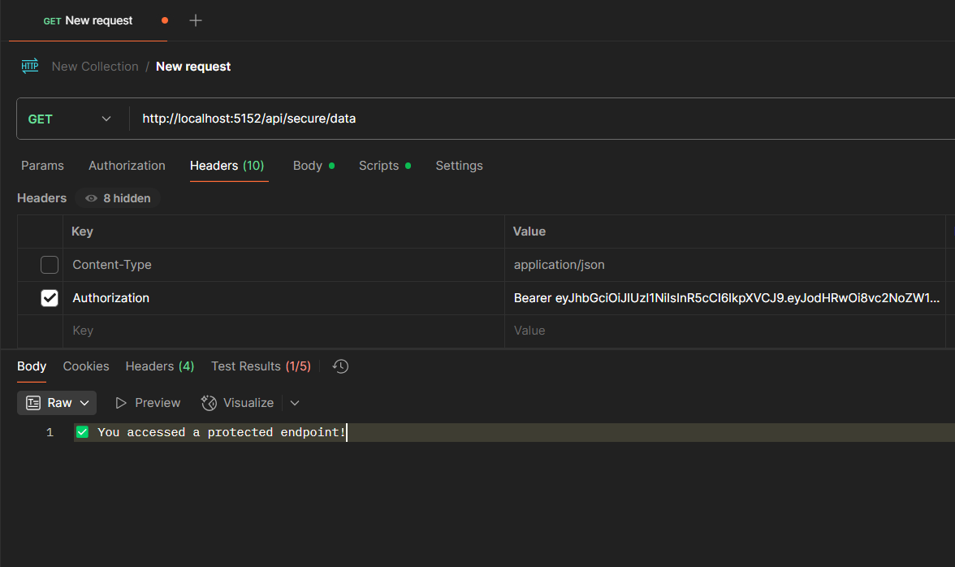

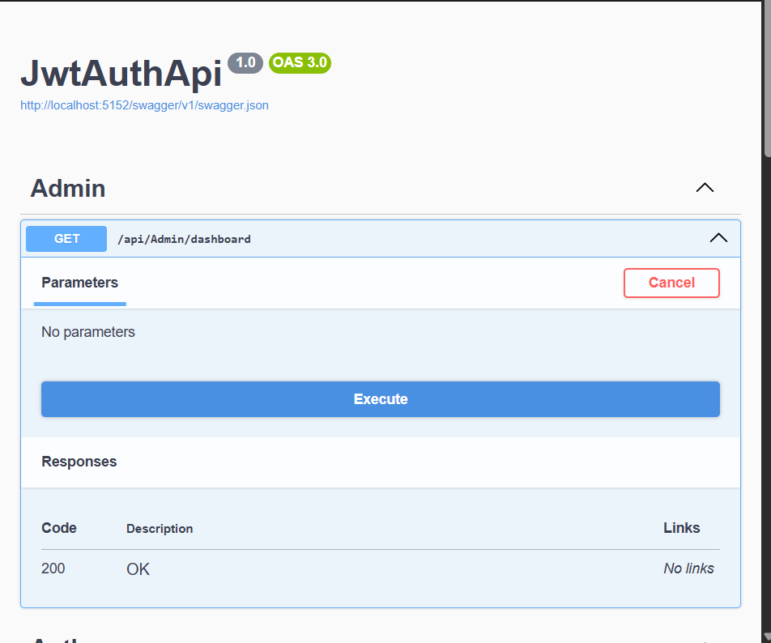

4:Validate JWT Token Expiry and Handle Unauthorized Access:  
  
Program:

[AuthCountroller.cs](http://authcountroller.cs)

using Microsoft.AspNetCore.Mvc;

using Microsoft.IdentityModel.Tokens;

using System.IdentityModel.Tokens.Jwt;

using System.Security.Claims;

using System.Text;

using JwtAuthApi.Models;

namespace JwtAuthApi.Controllers

{

[ApiController]

[Route("api/[controller]")]

public class AuthController : ControllerBase

{

private readonly IConfiguration _configuration;

public AuthController(IConfiguration configuration)

{

_configuration = configuration;

}

[HttpPost("login")]

public IActionResult Login([FromBody] LoginModel model)

{

// Dummy login check — in real app, check against DB

if (model.Username == "admin" && model.Password == "password")

{

var token = GenerateJwtToken(model.Username);

return Ok(new { Token = token });

}

return Unauthorized();

}

private string GenerateJwtToken(string username)

{

var claims = new[]

{

new Claim(ClaimTypes.Name, username),

new Claim(ClaimTypes.Role, "Admin") // 🔐 Add Admin role claim

};

var key = new SymmetricSecurityKey(

Encoding.UTF8.GetBytes(_configuration["Jwt:Key"]));

var creds = new SigningCredentials(key, SecurityAlgorithms.HmacSha256);

var token = new JwtSecurityToken(

issuer: _configuration["Jwt:Issuer"],

audience: _configuration["Jwt:Audience"],

claims: claims,

expires: DateTime.Now.AddMinutes(60),

signingCredentials: creds

);

return new JwtSecurityTokenHandler().WriteToken(token);

}

}

}

[AdminCountroller.cs](http://admincountroller.cs):

using Microsoft.AspNetCore.Authorization;

using Microsoft.AspNetCore.Mvc;

namespace JwtAuthApi.Controllers

{

[ApiController]

[Route("api/[controller]")]

public class AdminController : ControllerBase

{

[HttpGet("dashboard")]

[Authorize(Roles = "Admin")]

public IActionResult GetAdminDashboard()

{

return Ok("Welcome to the admin dashboard.");

}

}

}

Program .cs:

using Microsoft.AspNetCore.Authentication.JwtBearer;

using Microsoft.IdentityModel.Tokens;

using System.Text;

using Microsoft.IdentityModel.Tokens;

var builder = WebApplication.CreateBuilder(args);

var configuration = builder.Configuration;

// JWT configuration

builder.Services.AddAuthentication("Bearer")

.AddJwtBearer("Bearer", options =>

{

options.TokenValidationParameters = new TokenValidationParameters

{

ValidateIssuer = true,

ValidateAudience = true,

ValidateLifetime = true,

ValidateIssuerSigningKey = true,

ValidIssuer = configuration["Jwt:Issuer"],

ValidAudience = configuration["Jwt:Audience"],

IssuerSigningKey = new SymmetricSecurityKey(

Encoding.UTF8.GetBytes(configuration["Jwt:Key"]))

};

// ✅ Handle expired or invalid tokens

options.Events = new JwtBearerEvents

{

OnAuthenticationFailed = context =>

{

if (context.Exception.GetType() == typeof(SecurityTokenExpiredException))

{

context.Response.Headers.Add("Token-Expired", "true");

}

// Optional: return custom error response

context.Response.StatusCode = 401;

context.Response.ContentType = "application/json";

return context.Response.WriteAsync("{\"error\": \"Token is invalid or expired.\"}");

}

};

});

builder.Services.AddAuthorization();

builder.Services.AddControllers();

builder.Services.AddEndpointsApiExplorer();

builder.Services.AddSwaggerGen();

var app = builder.Build();

app.UseSwagger();

app.UseSwaggerUI();

app.UseHttpsRedirection();

app.UseAuthentication();

app.UseAuthorization();

app.MapControllers();

app.Run();

Output: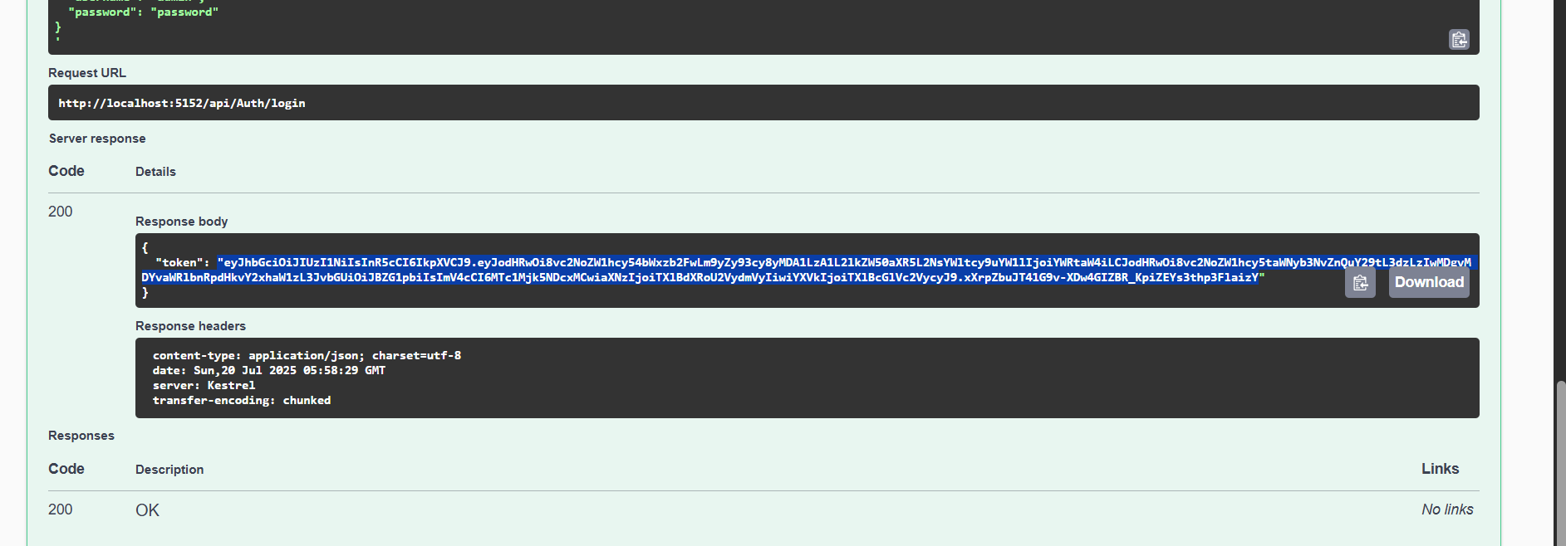

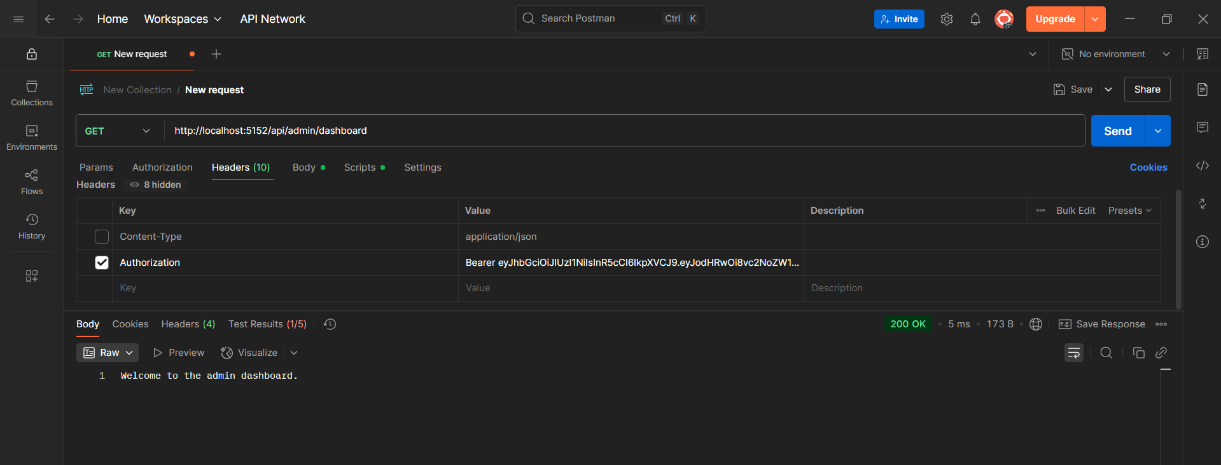

5 Kafka Integration with C#::

Producer App (Sender)

Program:

[program.cs](http://program.cs)

using Confluent.Kafka;

var config = new ProducerConfig { BootstrapServers = "localhost:9092" };

using var producer = new ProducerBuilder<Null, string>(config).Build();

Console.WriteLine("Enter messages to send to Kafka (type 'exit' to quit):");

while (true)

{

var message = Console.ReadLine();

if (message == "exit") break;

await producer.ProduceAsync("chat-topic", new Message<Null, string> { Value = message });

Console.WriteLine($"Sent: {message}");

}

Consumer Code

Program.cs

using Confluent.Kafka;

var config = new ConsumerConfig

{

BootstrapServers = "localhost:9092",

GroupId = "chat-group",

AutoOffsetReset = AutoOffsetReset.Earliest

};

using var consumer = new ConsumerBuilder<Ignore, string>(config).Build();

consumer.Subscribe("chat-topic");

Console.WriteLine("Listening for messages...");

try

{

while (true)

{

var result = consumer.Consume();

Console.WriteLine($"Received: {result.Message.Value}");

}

}

catch (OperationCanceledException)

{

consumer.Close();

}

